SAJC 2010 H2 Chemistry Prelim Paper 3 solution

1 | (a) | (i) | CH₃(CH₂)₄COOH + HOOCCH₂COOH + HOOC(CH₂)₇COOH
 |  | (ii) | These isomerism occurs in compounds in which free rotation of certain parts of a molecule relative to the rest is restricted by the presence of C=C double bonds (or ring structure).
 |  |  | 4 isomers
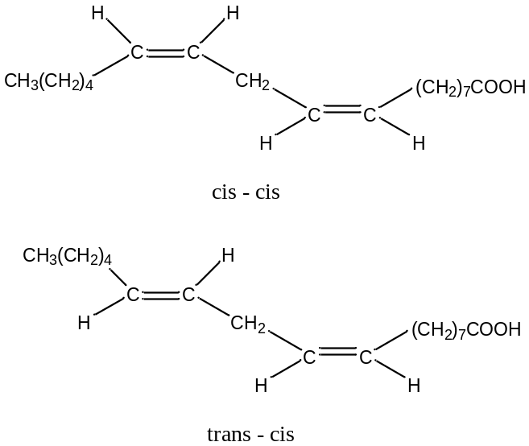

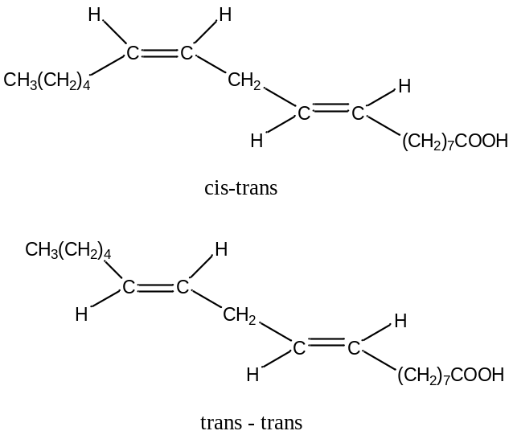

 |  | (iii) | Liquid or solid  Molecule is large and contains large no. of electrons, resulting in strong van der Waals’ forces / induced dipole-induced dipole interactions between molecules.
1 | (b) | (i) | 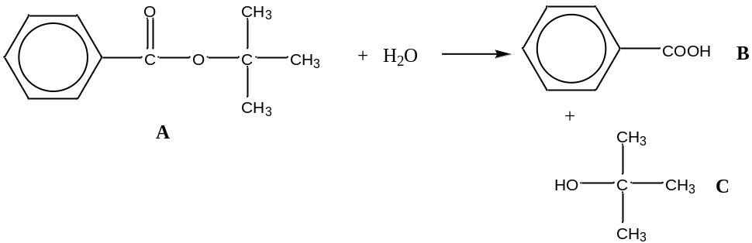
  A is neutral  A undergoes hydrolysis to give B and C | A has no phenol and carboxylic acid  A is an ester
  C is cannot be oxidised | C is a tertiary alcohol
  B is a white ppt | B is benzoic acid
 |  | (ii) | 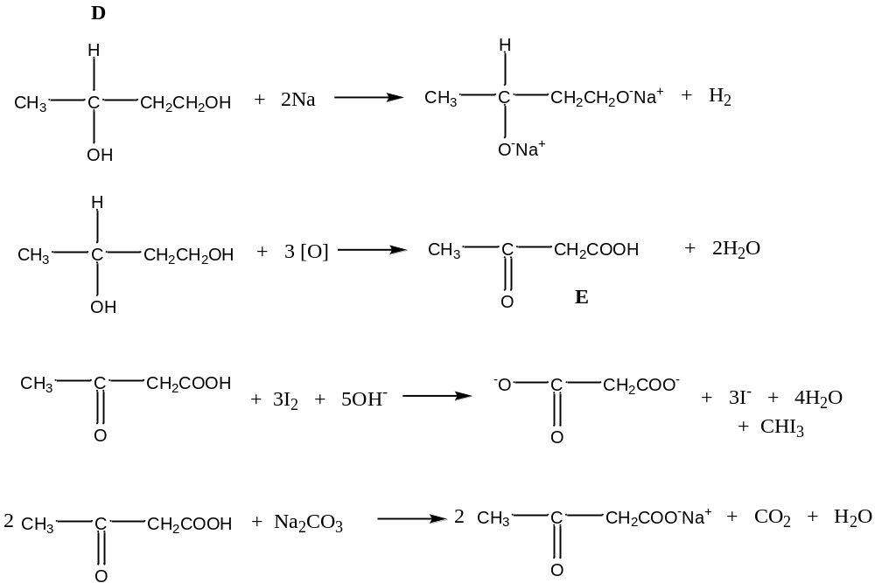
  D reacts with 2 moles of Na | D contains 2 OH groups
  D has no reaction with Na₂CO₃ | D does not have COOH
  E reacts with Na₂CO₃ to give CO₂ | E contains COOH
  D undergoes oxidation with KMnO₄. | D contains primary alcohol which oxidises to carboxylic acid
  E reacts with iodoform test | E contains methyl ketone or CH₃CO- group.  (CH₃CH(OH)- not acceptable as E is an oxidised product)
2 | (a) | (i) | Phenylalanine exists as zwitterions and hence, forms strong ion-dipole interactions with H₂O which provides sufficient energy to overcome the electrostatic forces of attractions / ionic bonding between the zwitterions.  Phenylamine is insoluble in water as the presence of non-polar bulky benzene ring which limits the formation of H-bond.
 |  | (ii) | Trimethylamine has a lower boiling point as the main interaction is permanent dipole-permanent dipole interaction /VDW while for dimethylamine, H-bond exists which is a stronger interaction.  Hence, more energy is needed to break the H-bonds.  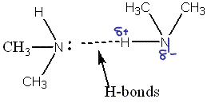
 |  | (iii) | The lone pair of electrons on N in trimethyamine is more available for protonation due to the presence of 3 electron donating methyl groups.  The lone pair of electrons on N in phenylamine is delocalised into the benzene ring, making it less available for protonation.
2 | (b)  (b) | (i)  (i) | 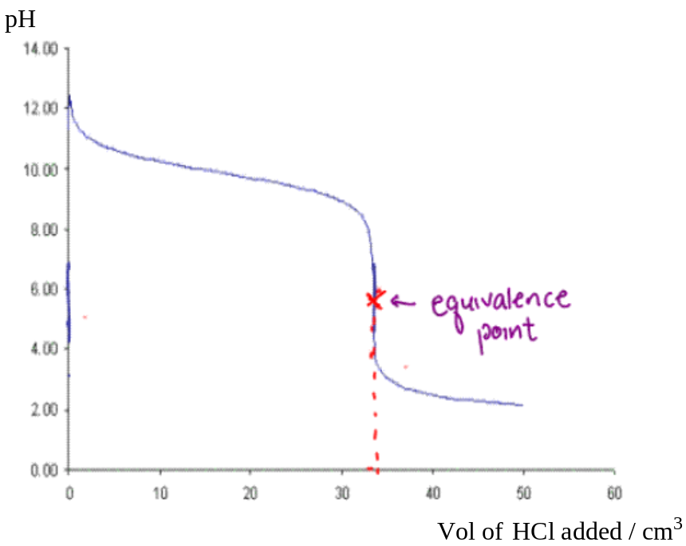  When HCl is added, trimethylamine is neutralised and pH decreased.  The rate of decrease in pH was slowed down due to the formation of buffer.  As more HCl was added, the buffer broke down as more trimethylamine was  neutralised.  The pH decreased rapidly and trimethylamine was completely neutralised at  33 cm³.  The pH at equivalence point is less than 7 due to the hydrolysis of the acidic salt, producing excess H₃O⁺.  OR (CH₃)₃NH⁺ + H₂O 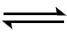 (CH₃)₃N + H₃O⁺  After neutralisation, the pH decreased slowly until constant due to addition of excess HCl.
 |  | (ii) | Equivalence point indicated on graph  Any indicator except for phenolphthalein  Working pH for indicator falls within the region of rapid pH change in the titration curve.
 | (c) | (i) | 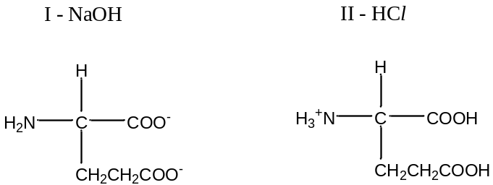
 |  | (ii) | 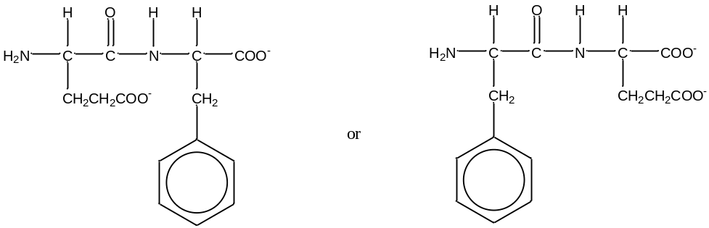
3 | (a) | (i) | The high charge density of Fe³⁺ ion causes hydrolysis, producing acidic solution with H₃O⁺.  Fe(H₂O)₆³⁺(aq) + H₂O [Fe(H₂O)₅OH]²⁺(aq) + H₃O⁺(aq)
3 | (a) | (ii) | Fe³⁺(aq) + e Fe²⁺(aq) E⁰ = + 0.77V  Cu²⁺(aq) + 2e Cu(s) E⁰ = + 0.34V  Overall equation: 2Fe³⁺(aq) + Cu(s) 2Fe²⁺(aq) + Cu²⁺(aq)  Eº_{cell} = + 0.43V  Since Eº value is positive, reaction is feasible.  The pale greenish blue solution observed is due to the mixture of Cu²⁺(aq) and Fe²⁺(aq) formed.
 |  | (iii) | Eº remains unchanged.
 | (b) | (i) | M_{r} = (mRT) = 1.56 x 8.31 x (273 + 180)  pV (32.3 x 10³ x 1 x 10⁻³)  ≈ 182
 |  | (ii) | M_{r} of AlCl₃ = 133.5  M_{r} of Al₂Cl₆ = 267  Let y = % of dimer, (100 – y) = % of monomer  267y + (100 – y) x 133.5 = 182  100  18200 = 267y + 13350 - 133.5y  3350 = 133.5y, y = 36.3  % of dimer = 36.3%
 |  | (iii) | Dimerisation involved bond formation.
 |  | (iv) | I 2AlCl₃(g) Al₂Cl₆(g)  The system tries to increase the pressure by increasing the no. of moles of gaseous molecules.  Equilibrium shifts to the left and the proportion of dimer would decrease.  II 2AlCl₃(g) Al₂Cl₆(g)  The system tries to increase the temperature by favouring the  exothermic process to produce more heat energy.  Thus, the equilibrium shifts to the right and proportion of dimer increases.
3 | (c) |  | 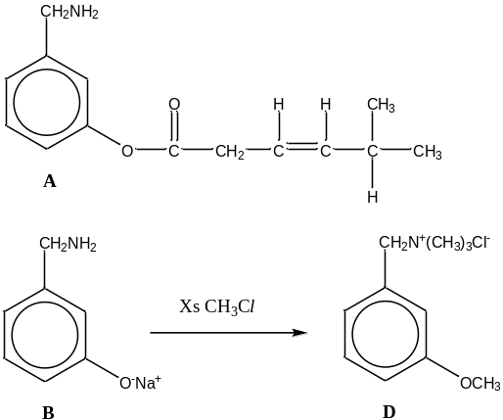  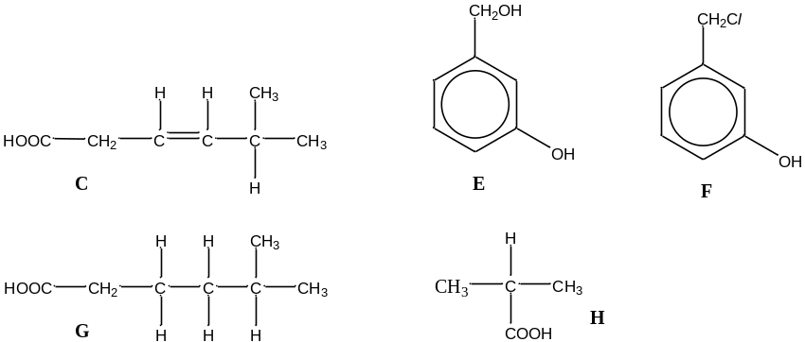  Synthesis of H  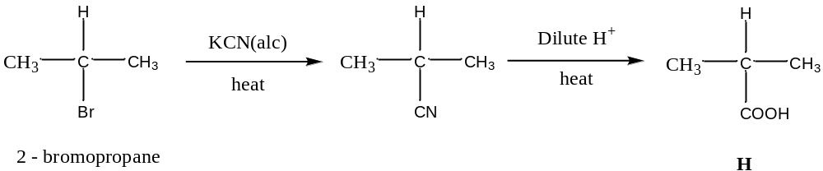
  A is basic | A contains amine group.
  A reacts with NaOH to produce two cpds. | A is an ester undergoes hydrolysis,  A is formed from a phenol and a carboxylic acid.
  B reacts with excess CH₃Cl to form D | B is a primary amine, which undergoes nucleophilic substitution, to form a quarternary salt, D.
  C liberates CO₂ with NaHCO₃ | C contains carboxylic acid.
  C, on hydrogenation, gives G, C₇H₁₄O₂, | C has contains 1 C=C bond.
  C forms two different compounds with KMnO₄. | C undergoes vigorous oxidation.
4 | (a) |  | Ca(s) + C(s) + 3/2 O₂(g) → CaCO₃(s)  The standard enthalpy change of formation of calcium carbonate is the enthalpy change when one mole of calcium carbonate is formed from its constituent elements in their standard states at 298K and 1 atmospheric pressure.
 | (b) | (i) | Heat evolved = (400 x 9.7) J  = 3.88 kJ
 |  | (ii) | ΔH_{r} = ( – 3.88 x 40.1) / 0.25  = – 622 kJ mol⁻¹
 |  | (iii) | Ca(s) + 2HCl(aq) → CaCl ₂(aq) + H₂(g) ------- Eq.(1) – 622 kJ mo⁻¹  CaCO₃(s) + 2HCl(aq) → CaCl₂(aq) + CO₂(g) + H₂O(l) ---- Eq.(2) – 95.0 kJ mol⁻¹  Eq.(1) + Reverse Eq.(2):  Ca(s) + CO₂(g) + H₂O(l) → CaCO₃(s) + H₂(g)  ΔH_{r} = – 622 + 95.0 = – 527 kJ mol⁻¹  – 527 = (ΔH_{f}º(CaCO₃) + 0) – [0 + ΔH_{f}º(CO₂) + (ΔH_{f}º(H₂O)]  – 527 = ΔH_{f}º(CaCO₃) – [(– 394) + (– 286)]  ΔH_{f}º(CaCO₃) = – 1207 kJ mol⁻¹
 | (c) | (i) | The entropy increases due to increase in the number of gaseous particles, resulting in more disorderliness in the system.
4 | (c) | (ii) | ΔG^{ө} = ΔH^{ө} - TΔS^{ө}  = +117 – (298 x 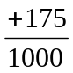) = +117 – 52.15  ≈ + 64.9 kJ mol⁻¹  Since ΔG^{ө} is positive, the decomposition is not feasible, i.e. MgCO₃ is more stable than MgO and CO₂ at room temperature.
 |  | (iii) | ΔG^{ө} = 0 = ΔH^{ө} - TΔS^{ө} = +117 – (T x )  T = 668K = 395⁰C  Above 668K, the decomposition reaction becomes feasible.
 |  | (iv) | MgCO₃ decomposes at a lower temperature or more easily than BaCO₃.  This is because Mg²⁺ ion, being smaller and higher charged than Ba²⁺, is able to polarise the large electron cloud of the carbonate ion more effectively, resulting in lower thermal stability in MgCO₃.
 | (d) | (i) | Reagents and conditions: Add KMnO₄/H⁺, heat  Observation: Ethylbenzene - Purple manganate(VII) decolorised, colourless gas  evolved formed white ppt with aqueous calcium hydroxide.  1,4-dimethylbenzene - Purple manganate(VII) decolourised but no  gas evolved.
 |  | (ii) | Reagents and conditions: aqueous bromine at room temperature  Observation: Phenylamine - Orange red solution decolourised, white ppt  formed.  Benzylamide - Orange red solution remained and no white ppt  formed.
 |  | (iii) | Reagents and conditions: Heat with aqueous sodium hydroxide, followed by HNO₃ and finally aqueous silver nitrate.  Observation: Chloroethylbenzene – White ppt formed.  Iodoethylbenzene – Yellow ppt formed.
5 | (a) | (i) | K_{a1} = 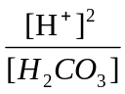  4.2 x 10⁻⁷ = 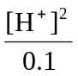  [H⁺] = √ (4.2 x 10⁻⁷ x 0.10) = 2.05 x 10⁻⁴ mol dm⁻³  pH = 3.69  Assumptions (any one):  - Since the weak carbonic acid dissociate slightly,  [H₂CO₃] at eqm ≈ initial [H₂CO₃]  - HCO₃⁻ does not dissociate further as K_{a2} << K_{a1}
 |  | (ii) | H₂CO₃ + NaOH → NaHCO₃ + H₂O  No. of mole of NaOH required = 0.100 x 20/1000 = 2 x 10⁻³ mol  No. of mole of NaHCO₃ salt formed = 2 x 10⁻³ mol  [HCO₃⁻] = 2 x 10⁻³ mol = 0.05 mol dm⁻³  40 x 10⁻³ dm³  HCO₃⁻ hydrolyses in water producing OH⁻:  HCO₃⁻ + H₂O H₂CO₃ + OH⁻  K_{b1} = 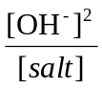  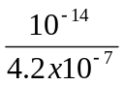 = 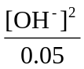  [OH⁻] = 3.45 x 10⁻⁵ mol dm⁻³  pOH = 4.46  pH = 14 – 4.46 = 9.54
 |  | (iii) | pH at B = 10.3  pH at B = pK_{a2} at max buffer capacity OR when [CO₃²⁻] = [HCO₃⁻]
 | (b) | (i) | Adding a small amount of H⁺:  H⁺ + HCO₃⁻ ➔ H₂CO₃  Adding a small amount of OH⁻:  OH⁻ + H₂CO₃ ➔ HCO₃⁻ + H₂O  A small amount of H⁺ and OH⁻ added is removed by a large reservoir of HCO₃⁻ and H₂CO₃. Thus, pH is remains almost constant.
5 | (b) | (ii) | 7.4 = pK_{a1} + lg 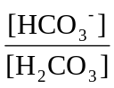  7.4 = 6.38 + lg  lg = 7.4 – 6.38 = 1.02  = 10.5
 | (c) |  | Any 2:  - More dense due to larger atomic mass and/or smaller radius.  - Hard and strong or higher melting point due to more delocalised electrons contributed from 3d and 4s subshells, resulting in stronger metallic bonding.  - 1st & 2nd I.E. relatively constant / increases minimally as electrons are added into the inner 3d subshell, resulting in increase in shielding effect canceling the increase in nuclear charge and hence insignificant increase in effective nuclear charge.
 | (d) | (i) | 2MnO₂(s) + 4OH⁻(aq) + O₂(g) → 2MnO₄²⁻(aq) + 2H₂O(l)
 |  | (ii) | 3MnO₄²⁻(aq) + 4H⁺(aq) → 2MnO₄⁻(aq) + MnO₂(s) + 2H₂O(l)  Disproportionation reaction has taken place.  Mn(VI) is oxidised to Mn(VII) and reduced to Mn(IV) at the same time.
 |  | (iii) | Because of the close similarity in energy of the 4s and 3d electron in Mn, it is able to lose all of the electrons in the 3d and 4s subshells, hence it can exhibit variable oxidation states.
 |  | (iv) | MnO₂(s) is a heterogeneous catalyst.  It works by providing a surface onto which H₂O₂ molecules are adsorbed and from which oxygen and water are desorbed.  The availability of 3d and 4s electrons allows the ready exchange of electrons between the MnO₂ catalyst and the H₂O₂ to form weak bonds, weakening the bonds in H₂O₂ and hence lowering the activation energy for the decomposition process.

